A MINI PROJECT REPORT ON

**FARMING MADE EASY USING MACHINE LEARNING**

A dissertation submitted in partial fulfilment of the

Requirements for the award of the degree of

**BACHELOR OF TECHNOLOGY**

in

**INFORMATION TECHNOLOGY**

***Submitted by***

**Ch. Indra Nehna (19B81A12D2)**

**K. Manasvini (19B81A12D4)**

**K. Srinija(19B81A12G6)**

***Under the esteemed guidance of***

**Mrs.Swathi Agarwal**

Assistant Professor, IT Department

CVR College of Engineering



**DEPPARTMENT OF INFORMATION TECHNOLOGY**

**CVR COLLEGE OF ENGINEERING**

ACCREDITED BY NBA, AICTE & Affiliated to JNTU-H

Vastunagar, Mangalpally (V), Ibrahimpatnam (M), R.R. District, PIN-501 510

2022-2023

**DEPARTMENT OF INFORMATION TECHNOLOGY**

**CERTIFICATE**

This is to certify that the Project Report entitled **“Farming Made Easy Using Machine Learning”** is a bonafide work done and submitted by **Ch. Indra Nehna(19B81A12D2)**, **K.Manasvini(19B81A12D4)** , **K.Srinja(19B81A12G6)** during the academic year 2022-2023, in partial fulfilment of requirement for the award of Bachelor of Technology degree in Information Technology from Jawaharlal Nehru Technological University Hyderabad, is a bonafide record of work carried out by them under my guidance and supervision.

Certified further that to my best of the knowledge, the work in this dissertation has not been submitted to any other institution for the award of any degree or diploma.

**INTERNAL GUIDE** **HEAD OF THE DEPARTMENT**

**Mrs. Swathi Agarwal Dr. Bipin Bihari Jayasingh**

Assistant Professor, IT Department Professor & HOD, IT Department

**PROJECT COORDINATOR EXTERNAL EXAMINER**

**Mrs.G. Sunitha Rekha**

Sr.Assistant Professor, IT Department

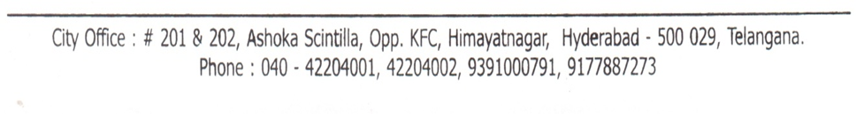

**ACKNOWLEDGEMENT**

The satisfaction of completing this project would be incomplete without mentioning our gratitude towards all the people who have supported us. Constant guidance and encouragement have been instrumental in the completion of this project.

First and foremost, we thank the Chairman, Principal, Vice Principal for availing infrastructural facilities to complete the mini project in time.

We offer our sincere gratitude to our internal guide **Mrs. Swathi Agarwal,** Assistant Professor, IT Department, CVR College of Engineering for her immense support, timely co-operation and valuable advice throughout the course of our project work.

We would like to thank the Professor In-Charge of Projects, **Mr. C.V.S Satyamurty**, Professor, Information Technology for his valuable suggestions in implementing the project.

We would like to thank the Head of Department, Professor **Dr. Bipin Bihari Jayasingh**, for his meticulous care and cooperation throughout the project work.

We are thankful to **Mrs. G. Sunitha Rekha,** Project Coordinator, Sr.Assistant Professor, IT Department, CVR College of Engineering for her supportive guidelines and for having provided the necessary help for carrying forward this project without any obstacles and hindrances.

We also thank the **Project Review Committee Members** for their valuable suggestions.

**DECLARATION**

We hereby declare that the project report entitled “Farming Made Easy using Machine Learning” is an original work done and submitted to IT Department, CVR College of Engineering, affiliated to Jawaharlal Nehru Technological University Hyderabad, Hyderabad in partial fulfilment of the requirement for the award of Bachelor of Technology in **Information Technology** and it is a record of bonafide project work carried out by us under the guidance of **Mrs. Swathi Agarwal, Assistant Professor, Department of Information Technology.**

We further declare that the work reported in this project has not been submitted, either in part or in full, for the award of any other degree or diploma in this institute or any other Institute or University.

**CH. INDRA NEHNA**

**(19B81A12D2)**

**K. MANASVINI**

**(19B81A12D4)**

**K. SRINIJA**

**(19B81A12G6)**

**ABSTRACT**

India being a rural nation, its economy transcendently relies upon agricultural yield development and unified agroindustry items. It is currently quickly advancing towards a specialized turn of events. India now is rapidly progressing towards technical development. Smart farming is changing the face of agriculture in India. Agriculture is the primary mainstay of the economy in our country. In recent years because of uncertain trends in climate and other fluctuations in the price trends, the price of the crop has varied to a larger level. Farmers remain oblivious of the uncertainties, which spoils the crops and causes massive loss. They are unaware of the crop price which would benefit them more. This application designed is handy, easy-to-use which provides accurate results in predicting the price of the crop. This framework utilizes Machine Learning’s Decision Tree Regression Algorithm to predict crop price. The attributes considered for prediction are rainfall, wholesale price index, month, and year. Consequently, the system gives an advance forecast to the farmers which grows the speed of profit to them and consequently the country's economy. This system also incorporates other attributes like weather forecast, crop recommendation is also implemented.

**LIST OF FIGURES**

|  |  |  |
| --- | --- | --- |
| **Figure No.** | **Title** | **Page No.** |
| 1 | Software Architecture diagram | 15 |
| 2 | Use case diagram | 16 |
| 3 | Activity diagram | 17 |
| 4 | Sequence diagram | 18 |
| 5 | Class diagram | 19 |
| 6 | Component diagram | 20 |
| 7 | Invalid User Login | 26 |
| 8 | Login Failed | 26 |
| 9 | Password Specifications Has to be fulfilled | 27 |
| 10 | Python Home Page | 32 |
| 11 | Python Versions | 33 |
| 12 | Different versions of python along with operating systems | 33 |
| 13 | Open downloaded python versions | 34 |
| 14 | Python Installation | 34 |
| 15 | Setup successful | 35 |
| 16 | Open Command Prompt | 35 |
| 17 | Checking availability of python version is installed | 36 |
| 18 | MySQL License Agreement | 36 |
| 19 | Choosing Setup File | 37 |
| 20 | Path Conflicts | 37 |
| 21 | Check Requirements | 38 |
| 22 | MySQL Installation | 38 |
| 23 | Installing/Updating the packages | 39 |
| 24 | Configuring the MySQL server and router | 39 |
| 25 | Type and Networking | 40 |
| 26 | Accounts and Roles | 40 |
| 27 | Windows Service | 41 |
| 28 | Apply Server Configuration | 41 |
| 29 | Server configuration has stopped | 42 |
| 30 | Product Configuration | 42 |
| 31 | Install Django | 43 |
| 32 | Install MySQL for Python | 43 |
| 33 | Install Pandas | 43 |
| 34 | Install scikit-learn | 43 |
| 35 | Install Matplotlib | 44 |
| 36 | Run Server | 44 |
| 37 | Server started, Open browser and enter URL | 45 |
| 38 | Home Page | 45 |
| 39 | Admin Login Page | 46 |
| 40 | Welcome Admin Page | 46 |
| 41 | Add New Schemes Page | 47 |
| 42 | New Schemes added Page | 47 |
| 43 | New Farmer SignUp Page | 48 |
| 44 | SignUp Process Completed Page | 48 |
| 45 | Farmer Login Page | 49 |
| 46 | Welcome Farmer Page | 49 |
| 47 | View Schemes Page | 50 |
| 48 | Crop Name Selection | 50 |
| 49 | Crop Price Forecasting Graph | 51 |
| 50 | Crop Price Prediction and Accuracy | 51 |

# LIST OF TABLES

|  |  |  |
| --- | --- | --- |
| **Table No.** | **Title** | **Pg. No** |
| 1 | Literature Review | 11 |

**TABLE OF CONTENTS**

**S. No. Topic Page No.**

**1.** **Introduction………………………………………………….…. 10**

1.1 Literature Survey……………………………………………. 11

**2. Software Requirement Specifications…………………………. 14**

2.1 Functional Requirements…………………………………….. 14

2.2 Non-Functional Requirements………………………………. 14

2.3 Hardware and Software Requirements……………………… 15

**3. Design…………………………………………………………… 16**

**4. Implementation………………………………………………… 21**

4.1 Authentication………………………………………………. 23

**5. Testing…………………………………………………………. 26**

Conclusion……………………………………………………… 28

Future Enhancements…………………………………………... 29

References……………………………………………………… 30

Appendix A - Abbreviations…………………………………… 31

Appendix B - Software Installation Procedure………………… 32

Appendix C - Software Usage Process………………………… 45

**CHAPTER 1**

**INTRODUCTION**

Agriculture is the backbone of every economy. From ancient period, agriculture is considered as the main and the foremost culture practiced in any region. India is rapidly progressing towards new innovations. Smart farming is becoming more popular in our country. In the status quo, the farmers and the consumers find it difficult in the real world to determine the accurate prices of crops without having prior knowledge of the fluctuating trend prices or weather conditions. Accordingly, innovation will end up being helpful to agriculture. There are multiple ways to increase and improve the crop yield and the quality of the crops.

In the past few years, we have seen a lot of fluctuation in the prices of crops. This has increased the rate of crop damage produced each year. The main aim of this prediction system is to ensure that the farmers get a better idea about their yield and deal with the value risk.

Weather is also highly unpredictable these days. It also affects the crop production. Our application will also forecast the weather helping the farmer to make correct decisions regarding field ploughing, field harvesting etc. It will also show the best suited crop based on cultivation date and month and location details, thereby maximizing the yield. This is based on finding proper regional datasets that help us in achieving high accuracy and better performance.

Farmers should know about their location, date of cultivation of their crop. Our system is a web application used for the Crop Price Prediction and Estimation with the help of machine learning and prediction algorithms like K-Nearest Neighbour, Decision Tree and Random Forest to identify the most accurate model and then process it.

**LITERATURE REVIEW**

|  |  |  |
| --- | --- | --- |
| Referred Papers | Name Of the author(s) | Extracted Topics |
| Price Forecasting System Using Supervised Machine Learning Alogrithms https://www.irjet.net/archives/V6/i4/IRJET-V6I41037.pdf[1] | Rachana P , Rashmi, Shravani , Shruthi , Seema Kousa | KNN algorithm |
| Prediction of Crop Yield Using Data Mining  http://ijcsn.org/IJCSN-2019/8-3/Prediction-of-Crop-Yield-Using-Data-Mining.pdf[2] | Nishiba Kabeer,  Dr.Loganathan, Cowsalya.T | Crop year, area and rainfall values |
| Agro-Genius: Crop Prediction using Machine Learning  https://ijisrt.com/assets/upload/files/IJISRT19OCT1880.pdf.pdf[4] | Thayakaran Selvanayagam, Suganya S | Random   forest  algorithm |
| Design And Implementation Of Crop Yield  Prediction Model In Agriculture https://ijisrt.com/assets/upload/files/IJISRT19OCT1880.pdf.pdf[7] | Sangeeta, Shruthi G | Random forest & Decision  tree algorithm |
| Smart Agricultural Crop Prediction Using Machine Learning  https://www.xajzkjdx.cn/gallery/162-may2020.pdf[9] | Naveen Kumar P R, Manikanta K B, Amith Mali Patil | Random forest and Decision tree algorithm |
| Crop Price Prediction System using Machine learning Algorithms https://www.questjournals.org/jses/papers/Vol6-issue-1/B06011420.pdf[11] | Pandit Samuel | Decision tree algorithm |

**Table 1:** Literature Review

[1]. In the recent years there has been an inconsistency in the prices of multiple crops which in turn has increased the menace encountered by the Farmers. The main purpose of the Forecasting System is to ensure that the Farmers make a better-informed decision and manage the price risk. In the paper the emphasis is on machine learning technique to predict the Price of the Crop using the Naïve Bayes Algorithm and KNN Algorithm. The price of the crop is determined by recognizing the patterns in our training dataset which is given as one of the inputs to the Algorithm. The inputs values for the parameters (Yield, Rainfall, Minimum Support Price, and Maximum Trade) are taken by the user and fed to the algorithm. The other Parameters to the Algorithm are Probability, New Record Input and number of Dataset Parameters.

[2]. Crop prediction is that the art of predicting crop yields and manufacture before the yield really takes place. This process is to create a user-friendly interface for farmers, which gives the prediction of production using Data Mining techniques like Regression and Clustering based on available dataset. Before harvest prediction was done by considering the farmer’s knowledge on a selected field and crop. This work presents a system that uses data processing strategies so as to predict the analyzed datasets. The anticipated sort can specify the yielding of crops. The crop information base consists of farm data like crop varieties, crop year, area and rainfall. The knowledge-based additionally contains of zones furthermore district information.

[3]. Agriculture is the major economic force in our country. Ithas moderate climate throughout the year in most parts of the country. As the country is small, cultivated crops are distributed all over the country, because of that a reasonable market price is remaining as a challenging issue for farmers. This system is using machine learning and evaluates the crop price prediction by using Random Forest algorithm.

[4]. Agriculture is something that individuals have started to finish up moderate on, disregarding that it's miles what is holding us alive. The system aims at predicting or forecasting the crop yield by learning the past data of the farming land. By considering various factors such as rainfall, yield and other entities the system builds a predicting a model using machine learning techniques. Here we make use of different machine learning techniques such Random Forest, Polynomial Regression, Decision Tree. Performance is evaluated based on predicted accuracy.

[5]. Choosing a best crop which gives maximum yield and profit is very important to every farmer in agriculture field. Thus, by implementing technology in agriculture results in higher yields and improved quality of final product. This system is proposed to provide help to the farmers for expecting the best amount for their crops and for predicting the best price for the crops. This also helps the farmers to check previous prices of different commodities. The system can predict crops using Random Forest, Polynomial Regression and Decision Tree algorithms.

[6]. Crop price prediction is an important agricultural problem. Each and every farmer always tries to know, how much price he will get from his expectation. In the past, price prediction was calculated by analyzing farmer's previous experience on a particular crop. Accurate information about history of crop yield is an important thing for making decisions related to price prediction of the crops. Therefore, this paper proposes an idea to predict the price of the crop. However, as the conditions change day by day very rapidly, farmers are forced to cultivate more and more crops. Being this as the current situation, many of them don't have enough knowledge about the losses that might incur and are not completely aware of the benefits they get while farming them. The proposed system applies machine learning and prediction algorithm like Logistic Regression, Decision Trees, XGBoost, Neural Nets, and Clustering to identify the pattern among data and then process it. This in turn will help predict the target price of the crop.

**CHAPTER 2**

**SOFTWARE REQUIREMENT SPECIFICATIONS**

**2.1 FUNCTIONAL REQUIREMENTS**

Following are various functional requirements of the project:

* + - Farmer should be able to register by name, email, password.
    - Farmer should be able to login using registered name and password.
    - Admin should be able to login with his authenticated credentials.
    - Password should contain at least one number, xone uppercase and lowercase letter and at least 8 or more characters.
    - Admin should be able to add the required government schemes.
    - Farmer can view the difference between the predicted price of the crop and original price of the crop with the help of the graphical representation.
    - The results should be compared with the help of three algorithms.
    - Farmer should be able to find the best accuracy of the crop prediction result.
    - Farmer must be able to estimate the best crop to sow.

**2.2 NON-FUNCTIONAL REQUIREMENTS**

* + - Except 3.7.0 version no other python software version can be used.

**2.3 HARDWARE AND SOFTWARE REQUIREMENTS**

**HARDWARE REQUIREMENTS:**

* System i3 or above.
* Hard Disk minimum 40 GB
* RAM minimum 4 GB

**SOFTWARE REQUIREMENTS:**

* Operating System Windows 8 or above
* Programming Language Python 3.7
* Technologies Django Framework 2.1.7
* Database MySQL 5.5
* IDE IDLE, Visual Studio Code
* Python libraries NumPy, Pandas, scikit-learn, Matplotlib

**SOFTWARE ARCHITECTURE**

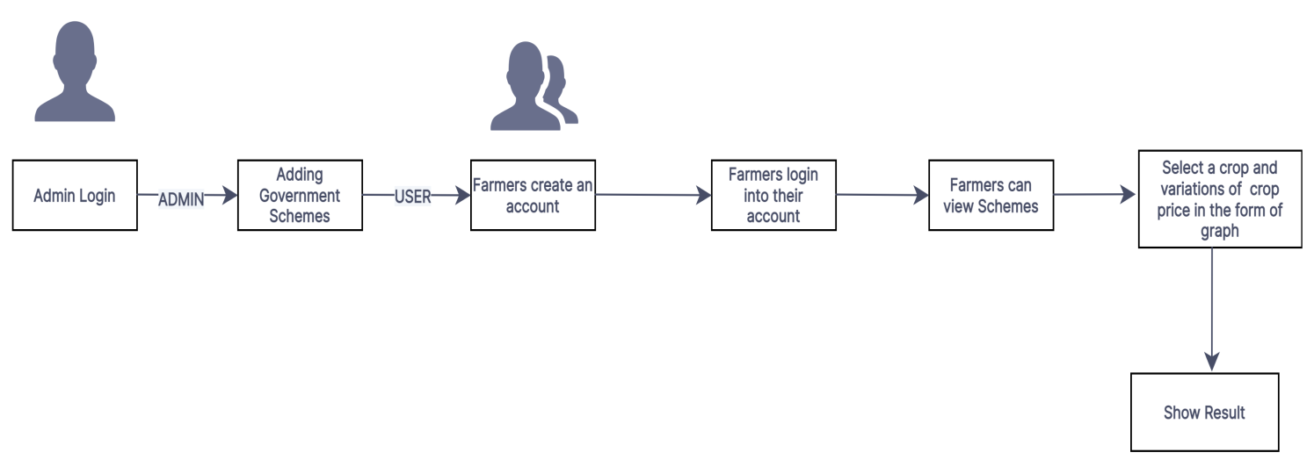

**Fig 1:** Software Architecture Diagram

**CHAPTER 3**

**DESIGN:**

**Use Case Diagram:**

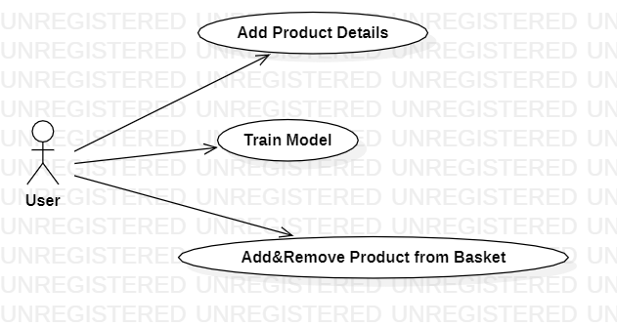

**Fig 2:** Use Case Diagram

**Activity Diagram:**

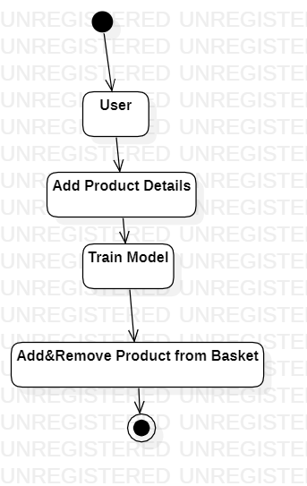

**Fig 3:** Activity Diagram

**Sequence Diagram:**

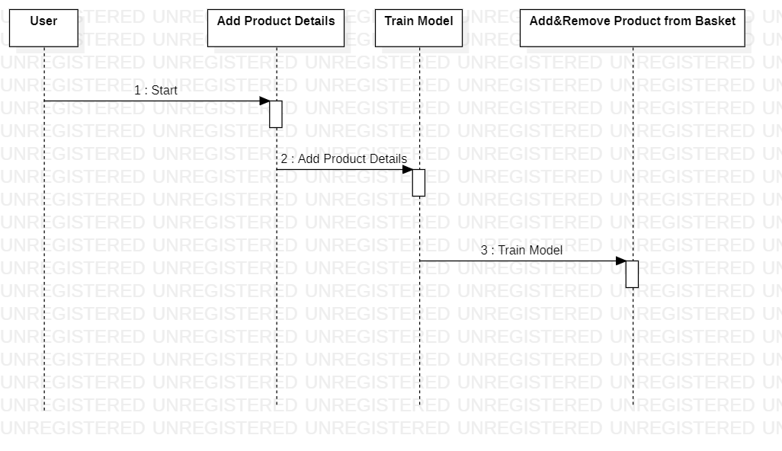

**Fig 4:** Sequence Diagram

**Class Diagram:**

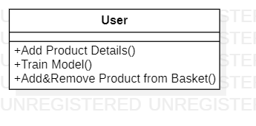

**Fig 5:** Class Diagram

**Component Diagram:**

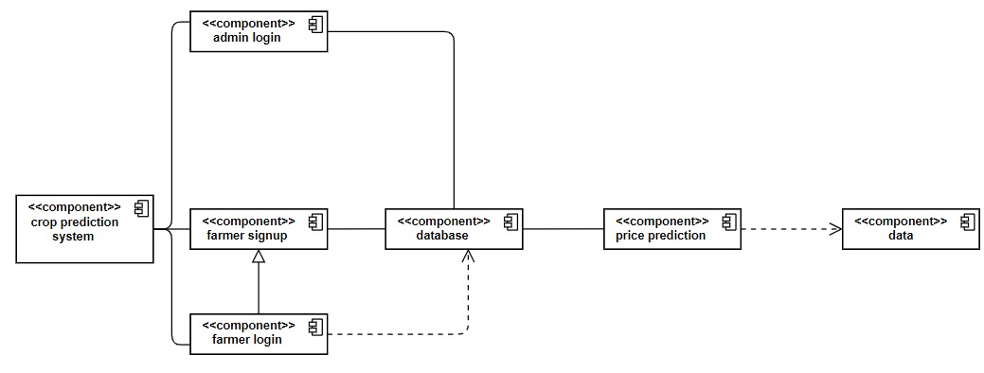

**Fig 6:** Component Diagram

**CHAPTER 4**

**IMPLEMENTATION:**

The application is implemented based on the following approaches:

* Django Framework : This is used for the creation of a web application.
* MySQL : It is a tool which can run on most platforms used to manage databases and servers and is mainly used for web-based applications.
* Pandas : It is used for handling missing data, performing operations on columns and rows, and transforming data .
* Scikit-learn : It is the most useful and robust library which is used for the implementation of various machine learning algorithms.
* NumPy : It is an open-source library for the Python programming language which is used for scientific computing and working with arrays i.e basically converting the numerical data.
* Matplotlib : It is an amazing multi-platform visualization library in Python for 2D plots of arrays.

**Modules:**

1. **New Farmer Signup:**

Using this module farmers can sign up with application

1. **Farmer Login:**

Farmer can login to application by using username and password given at signup time and then farmer can select crop name to get its predicted prices in different market. Farmer can view all schemes details launched from the government

1. **Admin Login:**

Admin can login to application by using ‘admin’ as username and password and then can add new schemes details.

**Important Code Snippets:**

**Code Snippet for Decision Tree Algorithm:**

dt_regression = DecisionTreeRegressor()

dt_regression.fit(X_train, Y_train.ravel())

predict = dt_regression.predict(X_test)

dt_mse = mean_squared_error(Y_test.ravel(),predict.ravel())

dt_accuracy = 1.0 - dt_mse

**Code Snippet for K Nearest Neighbour Algorithm:**

knn_regression = KNeighborsRegressor(n_neighbors=2)

knn_regression.fit(X_train, Y_train.ravel())

predict = knn_regression.predict(X_test)

knn_mse = mean_squared_error(Y_test.ravel(),predict.ravel())

knn_accuracy = 1.0 - knn_mse

**Code Snippet for Random Forest Algorithm:**

rf_regression = RandomForestRegressor()

rf_regression.fit(X_train, Y_train.ravel())

predict = rf_regression.predict(X_test)

rf_mse = mean_squared_error(Y_test.ravel(),predict.ravel())

rf_accuracy = 1.0 - rf_mse

**4.1 . AUTHENTICATION:**

This section deals with the implementation details of user authentication which includes user login and registration.

**Code Snippet for Admin Login Page:**

def AdminLoginAction(request):

global uname

if request.method == 'POST':

username = request.POST.get('t1', False)

password = request.POST.get('t2', False)

if username == 'admin' and password == 'admin':

uname = username

context= {'data':'welcome '+username}

return render(request, 'AdminScreen.html', context)

else:

context= {'data':'login failed'}

return render(request, 'ExpertLogin.html', context)

**Code Snippet for Farmer Login Page:**

def FarmerLoginAction(request):

global uname

if request.method == 'POST':

username = request.POST.get('t1', False)

password = request.POST.get('t2', False)

index = 0

con = pymysql.connect(host='127.0.0.1',port = 3306,user = 'root', password = 'Manasvini@2001', database = 'cropinfo',charset='utf8')

with con:

cur = con.cursor()

cur.execute("select username,password FROM signup")

rows = cur.fetchall()

for row in rows:

if row[0] == username and password == row[1]:

uname = username

index = 1

break

if index == 1:

context= {'data':'welcome '+uname}

return render(request, 'FarmerScreen.html', context)

else:

context= {'data':'login failed'}

return render(request, 'FarmerLogin.html', context)

**Code Snippet for Sign Up Page:**

def SignupAction(request):

if request.method == 'POST':

username = request.POST.get('t1', False)

password = request.POST.get('t2', False)

contact = request.POST.get('t3', False)

gender = request.POST.get('t4', False)

email = request.POST.get('t5', False)

address = request.POST.get('t6', False)

output = "none"

con = pymysql.connect(host='127.0.0.1',port = 3306,user = 'root', password = 'Manasvini@2001', database = 'cropinfo',charset='utf8')

with con:

cur = con.cursor()

cur.execute("select username FROM signup")

rows = cur.fetchall()

for row in rows:

if row[0] == username:

output = username+" Username already exists"

break

if output == 'none':

db_connection = pymysql.connect(host='127.0.0.1',port = 3306,user = 'root', password = 'Manasvini@2001', database = 'cropinfo',charset='utf8')

db_cursor = db_connection.cursor()

student_sql_query = "INSERT INTO signup(username,password,contact_no,gender,email,address) VALUES('"+username+"','"+password+"','"+contact+"','"+gender+"','"+email+"','"+address+"')"

db_cursor.execute(student_sql_query)

db_connection.commit()

print(db_cursor.rowcount, "Record Inserted")

if db_cursor.rowcount == 1:

output = 'Signup Process Completed'

context= {'data':output}

return render(request, 'Signup.html', context)

**CHAPTER 5**

**TESTING :**

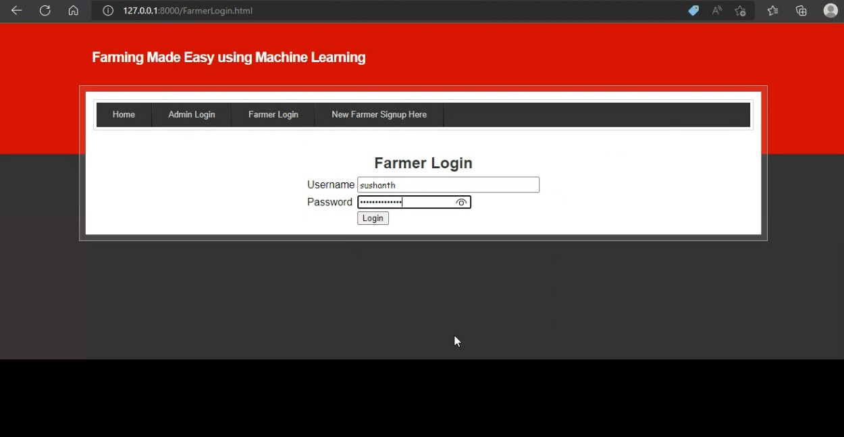

**Fig 7 :** Invalid User login

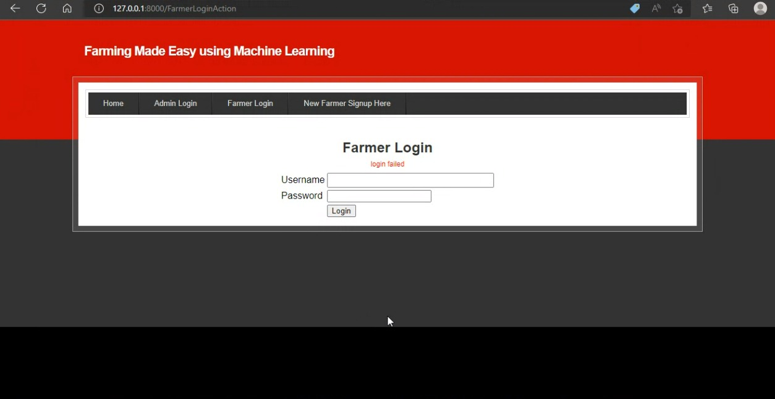

**Fig 8:** Login Failed

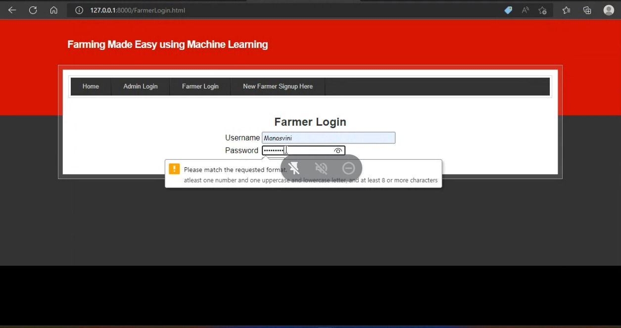

**Fig 9:** Password specifications has to be fulfilled.

**CONCLUSION**

This project is undertaken using machine learning and evaluates the performance by using K-Nearest Neighbor, Decision Tree and Random Forest algorithms. In our model among all the three algorithms Decision Tree gives the better yield prediction as compared to other algorithms.

As most extreme sorts of harvests will be secured under this system, farmers may become more acquainted with the yield which may never have been developed. The work exhibited the expected utilization of machine learning methods in foreseeing the harvest cost dependent on the given attributes. The created web application is easy to understand and the testing accuracy is over 90%.

**FUTURE ENHANCEMENTS**

We can extend our research by including chat portal which will also be useful for the farmers to communicate with each other from different areas and know the price of the crop for which they are selling.

We can extend our model by visualizing the crop details and shop location portal in a map which will help farmers to view the nearby district cultivation details and helps in purchasing the seeds. Fertilizer recommendation and Soil pH values helps to increase the crop yield further.

Language can pose as a barrier to the farmers. Since the majority of non-English speaking workers in India are native Hindi speakers. Hence, to make the website more user friendly, we can provide language translation.

**REFERENCES**

[1] Rachana, Rashmi, Shravani, Shruthi, Seema Kousar, Crop Price Forecasting System Using Supervised Machine Learning Algorithms, International Research Journal of Engineering and Technology (IRJET), Apr 2019.

[2] Nishiba Kabeer, Dr.Loganathan.D, Cowsalya.T, Prediction of Crop Yield Using Data Mining, International Journal of Computer Science and Network, June 2019.

[3] Gamage, A., & Kasthurirathna, D. Agro-Genius: Crop Prediction Using Machine Learning, International Journal of Innovative Science and Research Technology, Volume 4, Issue 10, October – 2019.

[4]Sangeeta, Shruthi G, Design And Implementation Of Crop Yield Prediction Model In Agriculture, International Journal Of Scientific & Technology Research Volume 8, Issue 01, January 2020

[5] Naveen Kumar P R, Manikanta K B, Venkatesh B Y, Naveen Kumar R, Amith Mali Patil, Journal of Xi'an University of Architecture & Technology, 2020.[6] Pandit Samuel, B.Sahithi , T.Saheli , D.Ramanika , N.Anil Kumar, Crop Price Prediction System using Machine learning Algorithms, Quest Journals Journal of Software Engineering and Simulation, 2020.

**APPENDIX A – ABBREVIATIONS**

1. **PIP** - Preferred Installer Program
2. **UML** – Unified Model Language
3. **RAM** – Random Access Memory
4. **SQL** – Structure Query Language
5. **NumPy** – Numerical Python
6. **IDE** – Integrated Development Environment
7. **IDLE** – Integrated Development and Learning Environment

**APPENDIX B – SOFTWARE INSTALLATION PROCEDURE**

1. **Python Installation:**

**Step 1:** Go to the official site to download and install python using Google Chrome or any other web browser or Click on the following link: [**https://www.python.org/**](https://www.python.org/)

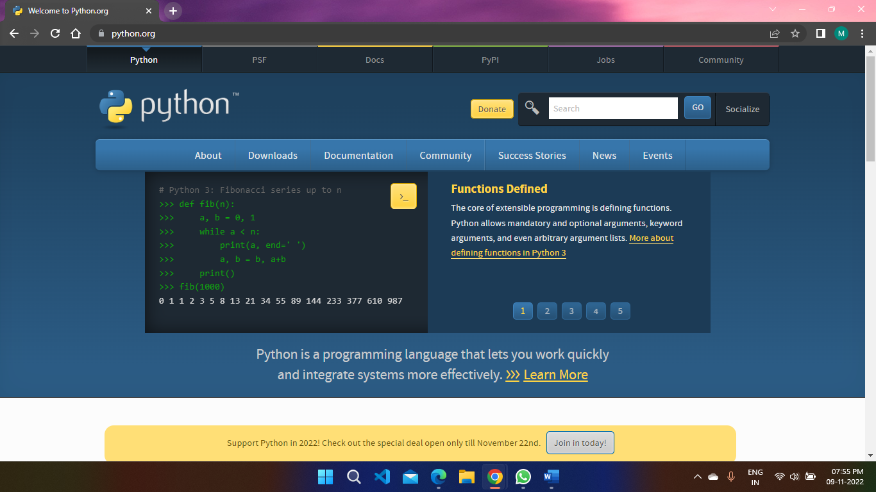

**Fig 10 :** Python Home Page

**Step 2:** You can either select the Download Python for windows 3.7.0 button or you can scroll further down and click on download with respective to their version. Here, we are downloading the python version for windows 3.7.0.

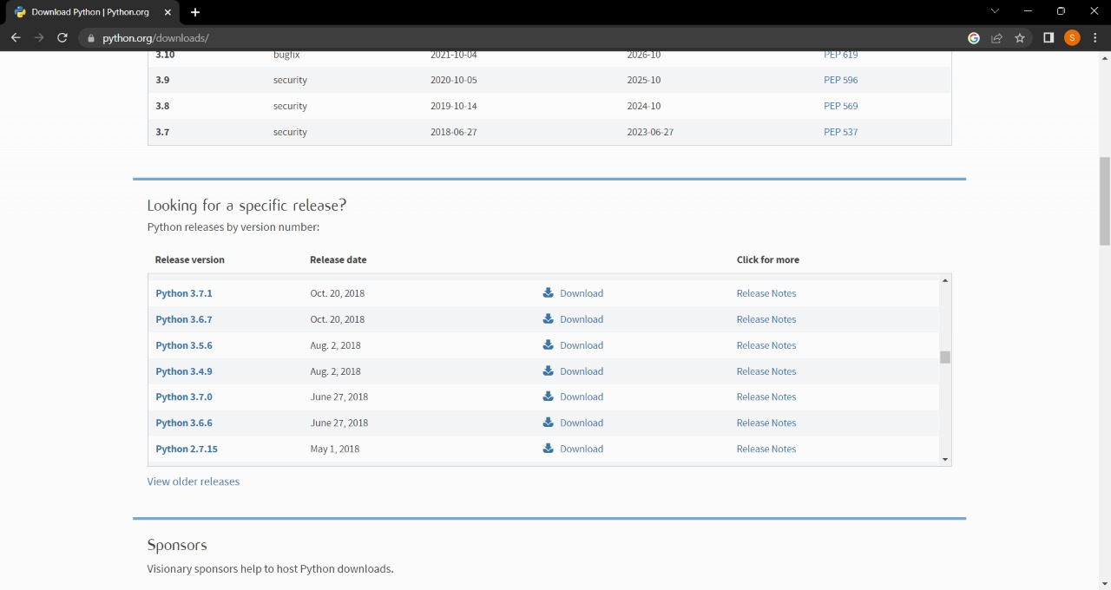 **Fig 11:** Python versions

**Step 3:** Here you see a different version of python along with the operating system.

**Fig 12:** Different versions of python along with the operating system

* To download Windows 64-bit python, you can select any one from the three options: Windows x86-64 embeddable zip file, Windows x86-64 executable installer or Windows x86-64 web-based installer.

Here first part regarding which version of python is to be downloaded is completed. Now we move ahead with the second part in installing python i.e., Installation.

**Note:** To know the changes or updates that are made in the version you can click on the Release Note Option.

### **Installation of Python:**

**Step 1:** Go to Download and Open the downloaded python version to carry out the installation process.



**Fig 13:** open downloaded python version

**Step 2:** Before you click on Install Now, make sure to put a tick on Add Python 3.7 to PATH.

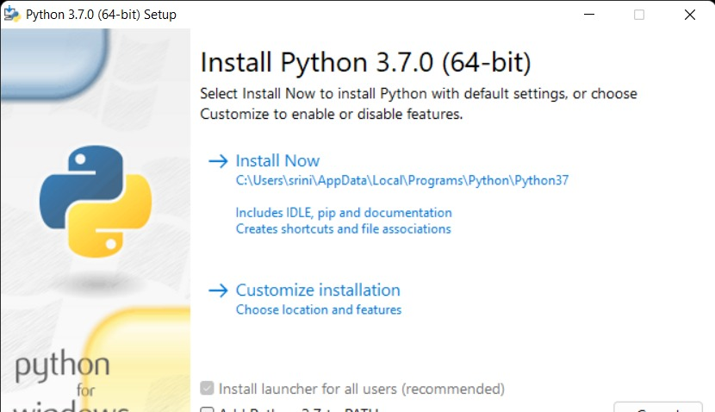

**Fig 14:** Python Installation

**Step 3:** Click on Install NOW After the installation is successful. Click on Close.

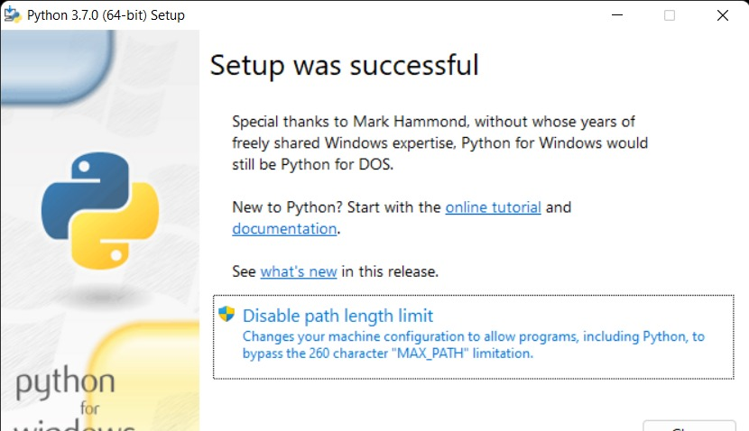

**Fig 15:** Setup successful

With these above three steps on python installation, you have successfully and correctly installed Python. Now is the time to verify the installation.

**Note:** The installation process might take a couple of minutes.

### Verify the Python Installation

**Step 1:** Click on Start button.

**Step 2:** In the Windows Run Command, type “cmd”.

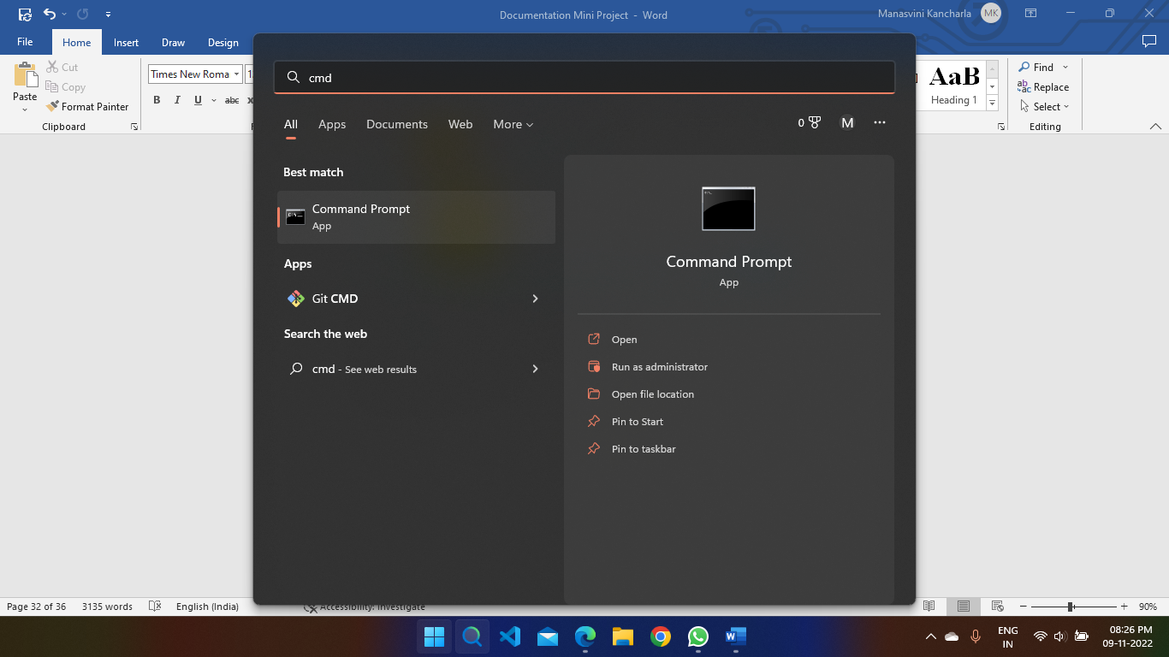

**Fig 16:** Open Command Prompt

**Step 3:** Open the Command prompt option.

**Step 4:** Let us test whether the python is correctly installed. Type **python –V** and press Enter.

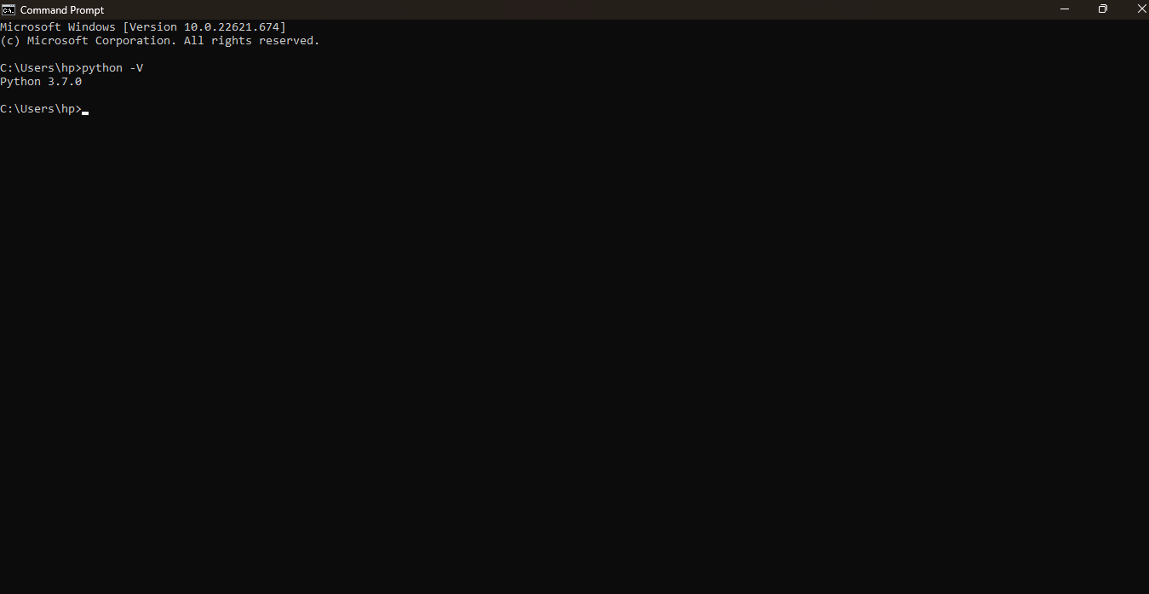

**Fig 17:** Checking availability of python version is installed

1. **MySQL Installation:**

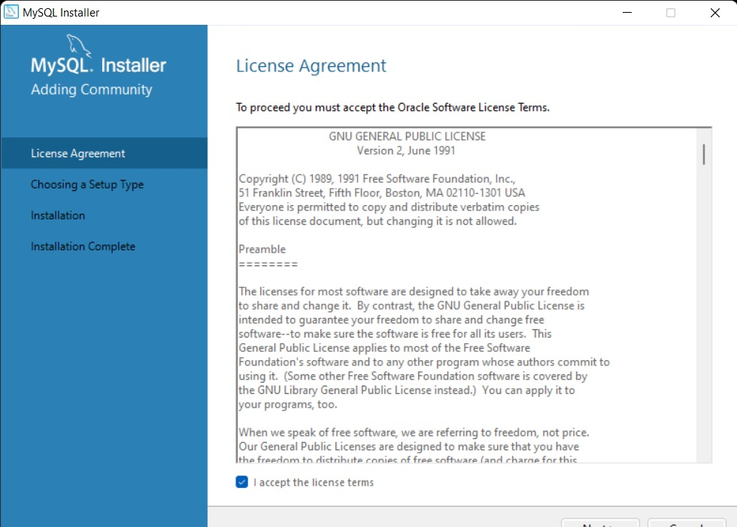

**Fig 18:** MySQL License Agreement

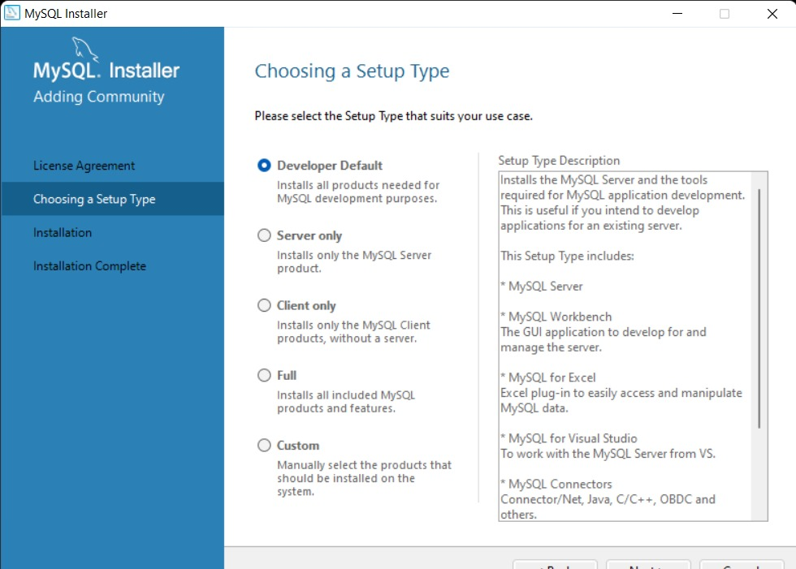

**Fig 19:** Choosing Setup Type

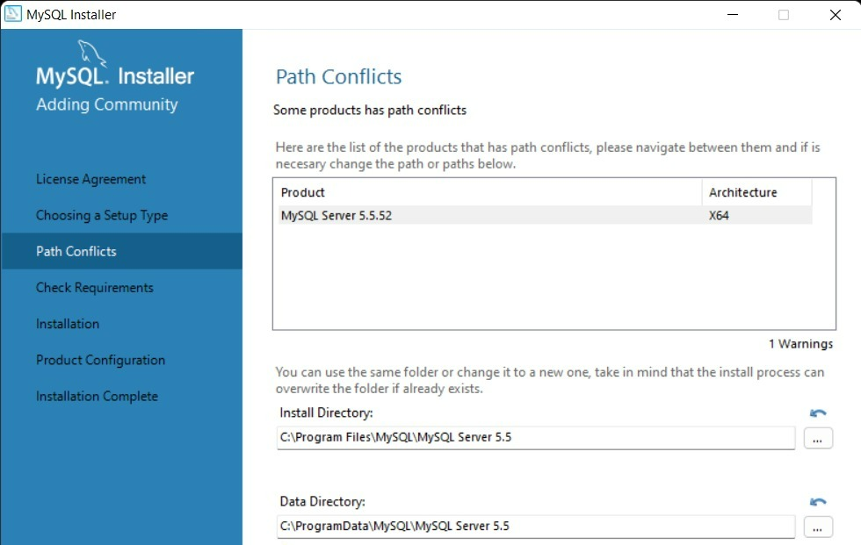

**Fig 20:** Path Conflicts

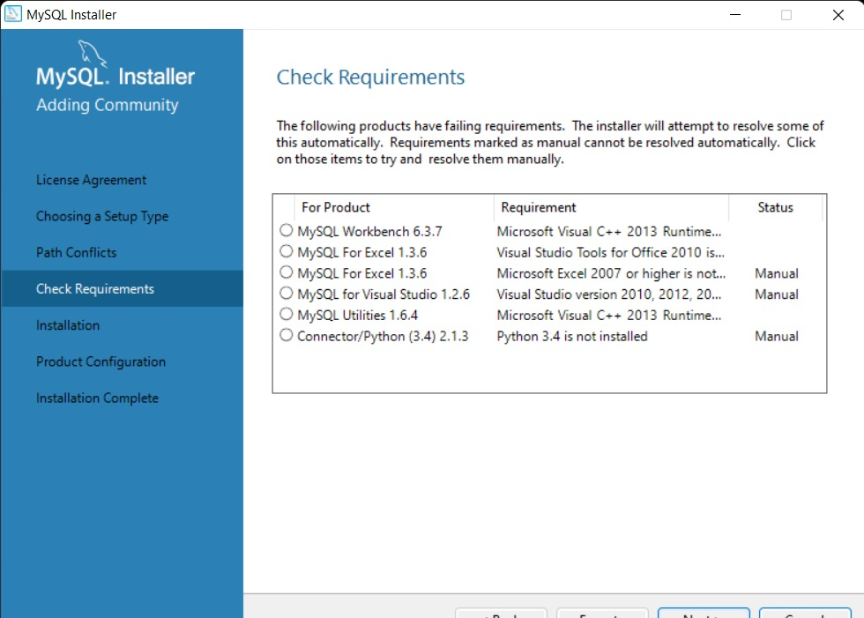

**Fig 21:** Check Requirements

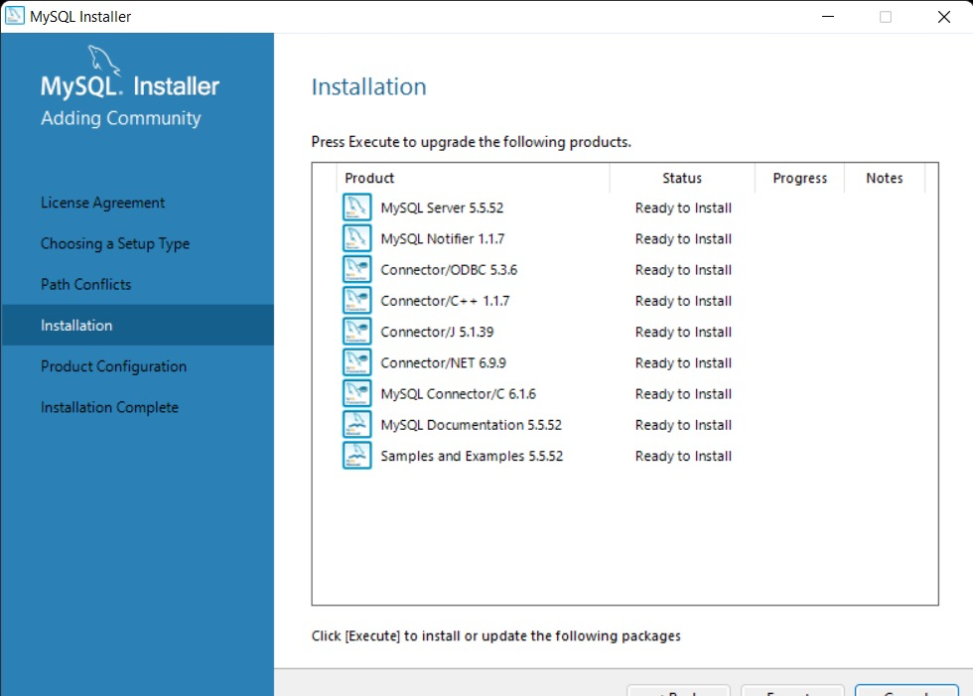

**Fig 22:** MySQL Installation

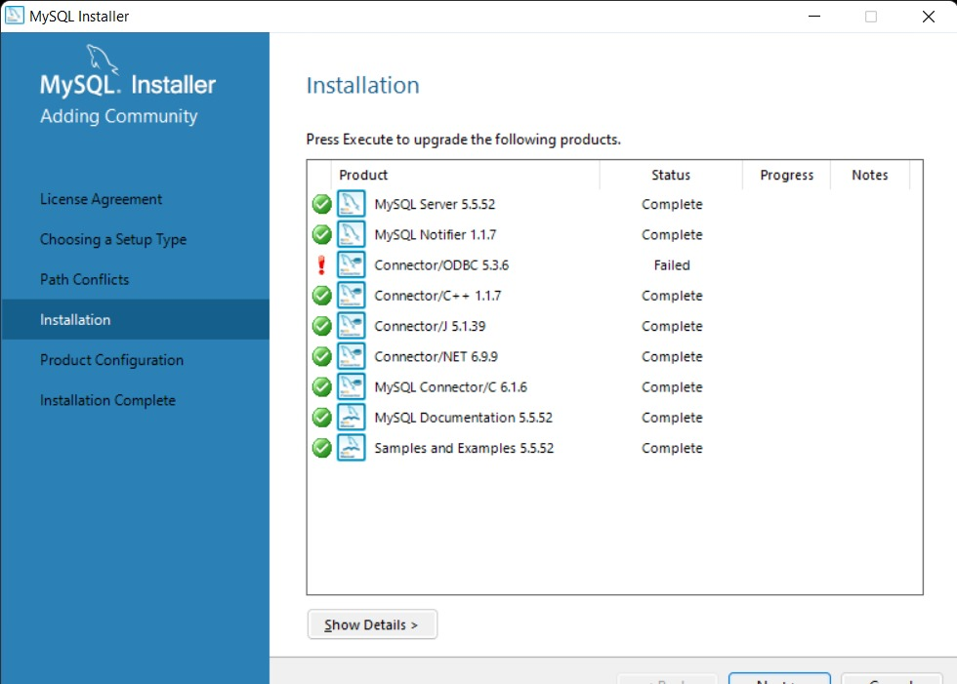

**Fig 23:** Installing/Updating the packages

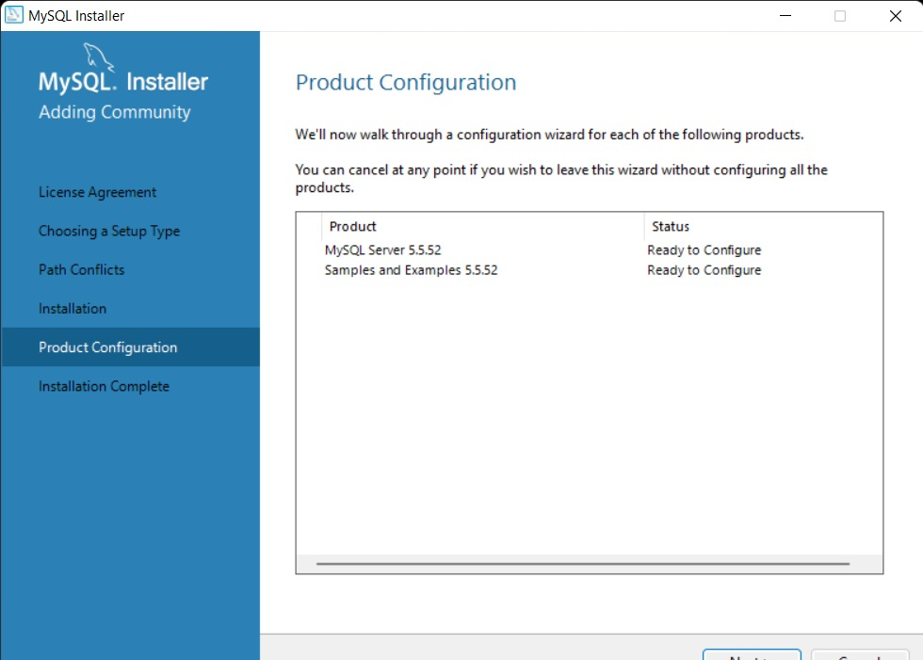

**Fig 24:** Configuring the MySQL server and router

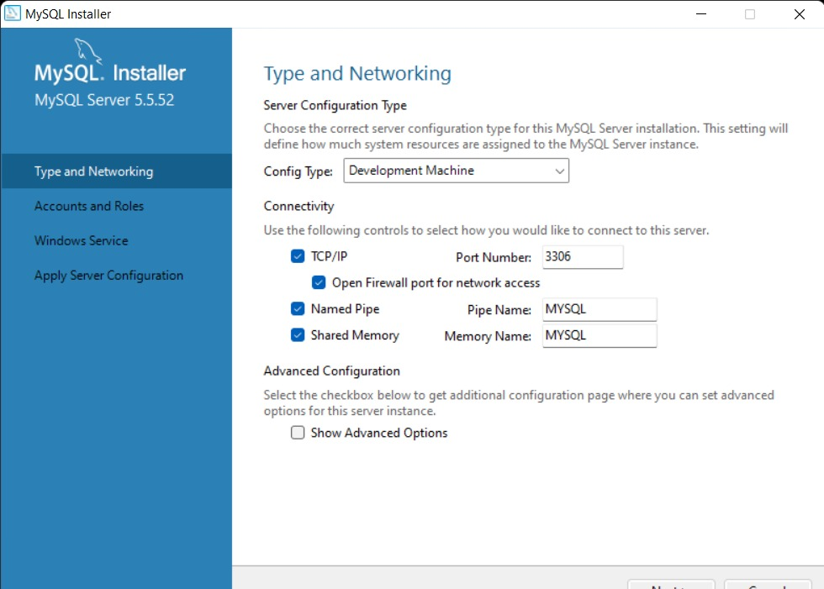

**Fig 25:** Type and Networking

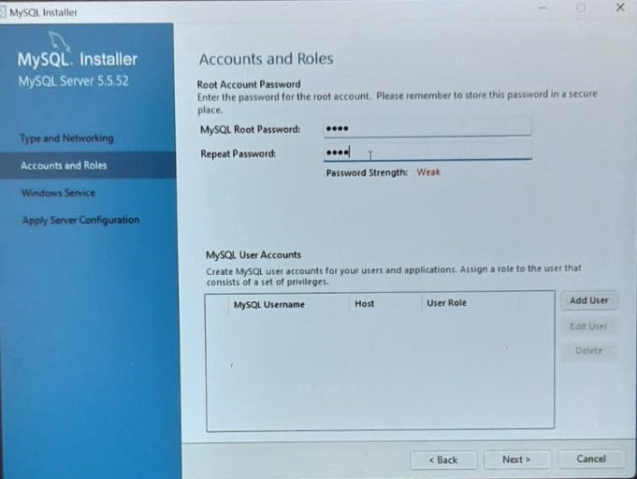

**Fig 26:** Accounts and Roles

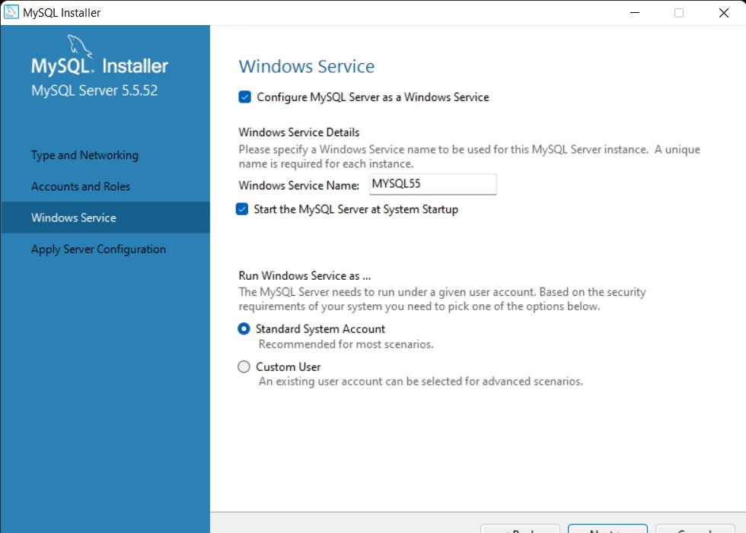

**Fig 27:** Windows Service

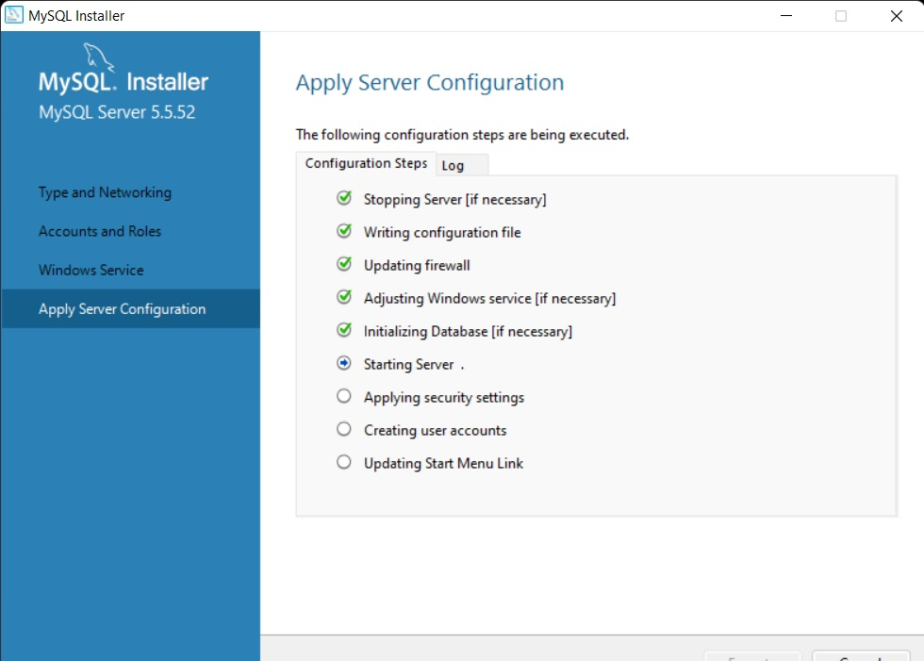

**Fig 28:** Apply Server Configuration

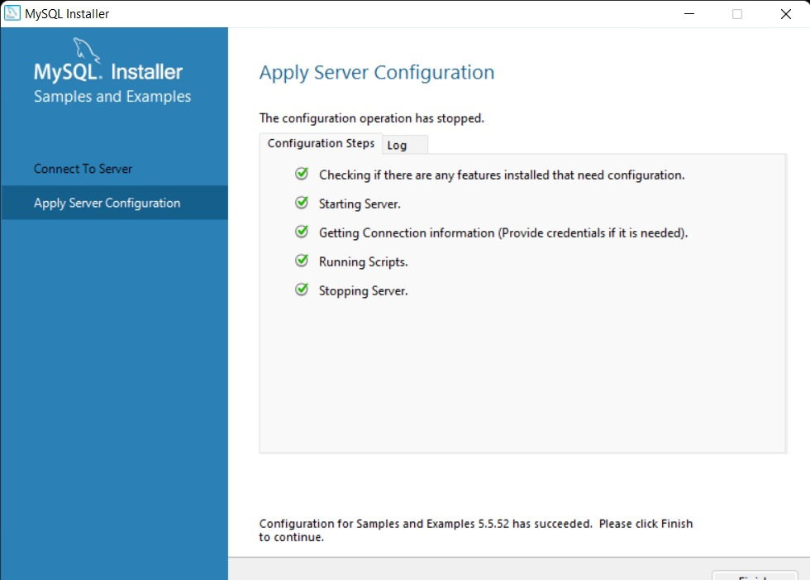

**Fig 29:** Server Configuration has stopped

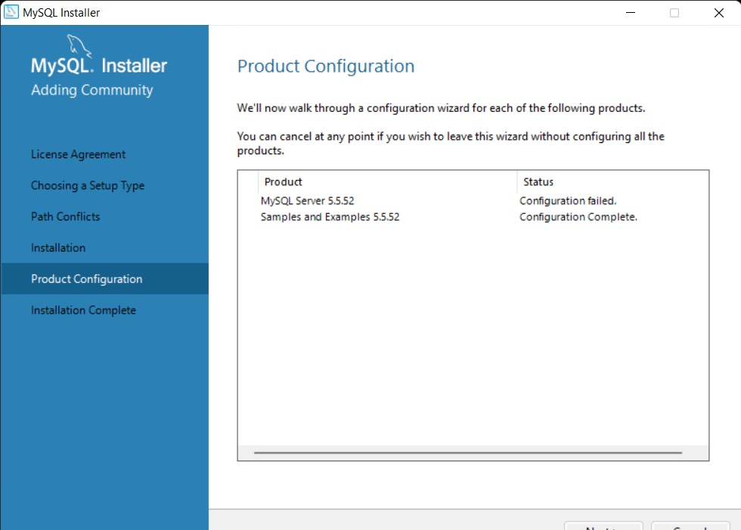

**Fig 30:** Product Configuration

1. **Django Installation:**

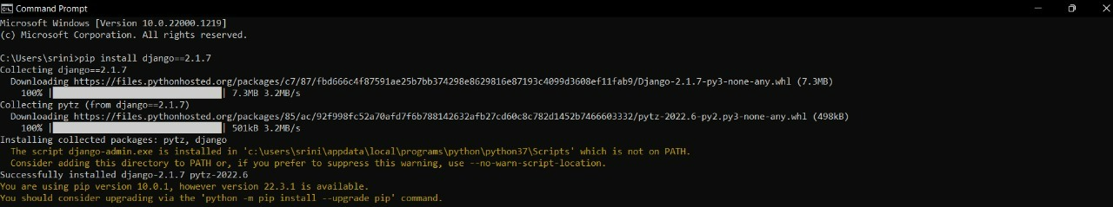

**Fig 31:** Install Django

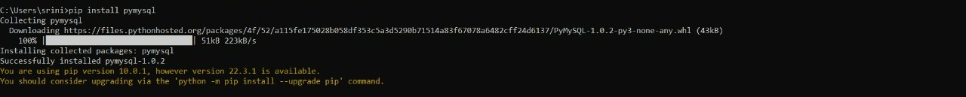

**Fig 32:** Install MySQL for Python

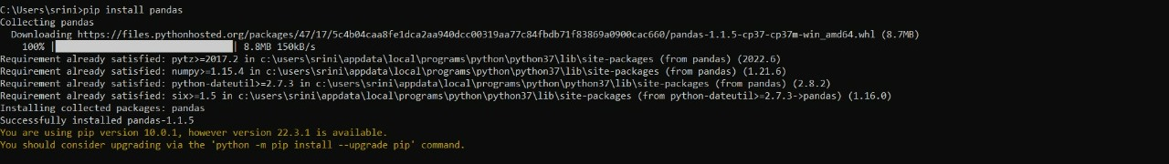

**Fig 33:** Install Pandas

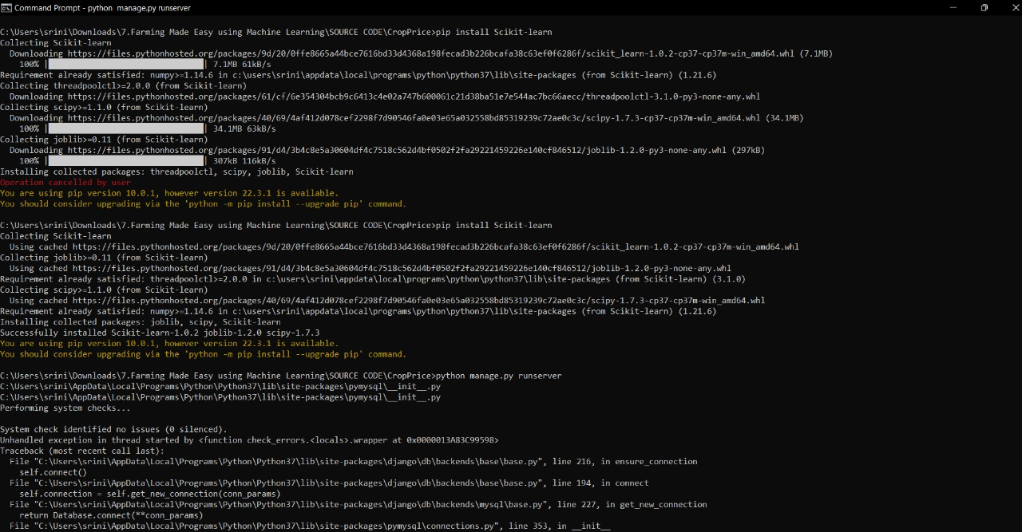

**Fig 34:** Install scikit-learn

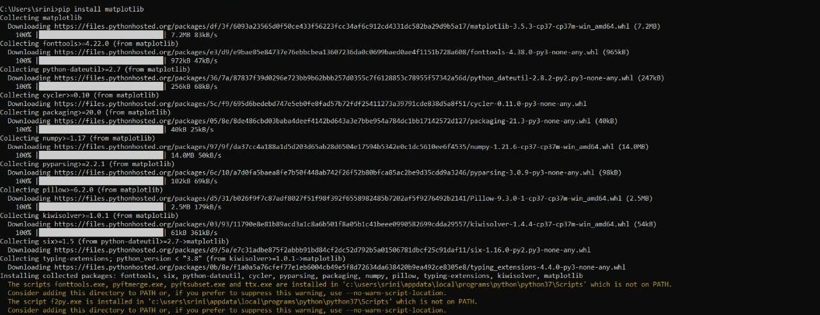

**Fig 35:** Install matplotlib

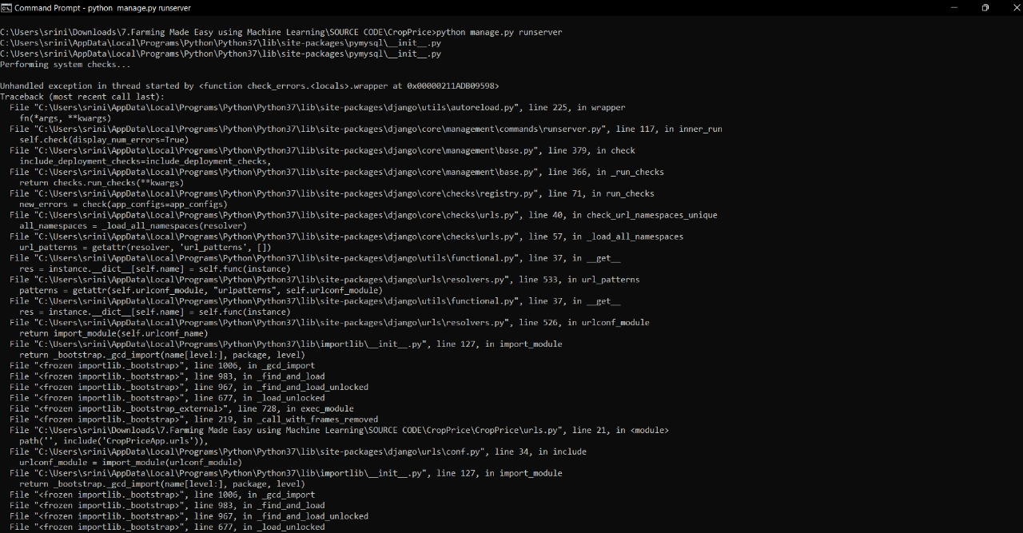

**Fig 36:** Run server

**APPENDIX C – SOFTWARE USAGE PROCESS**

1. **Starting the Application:**

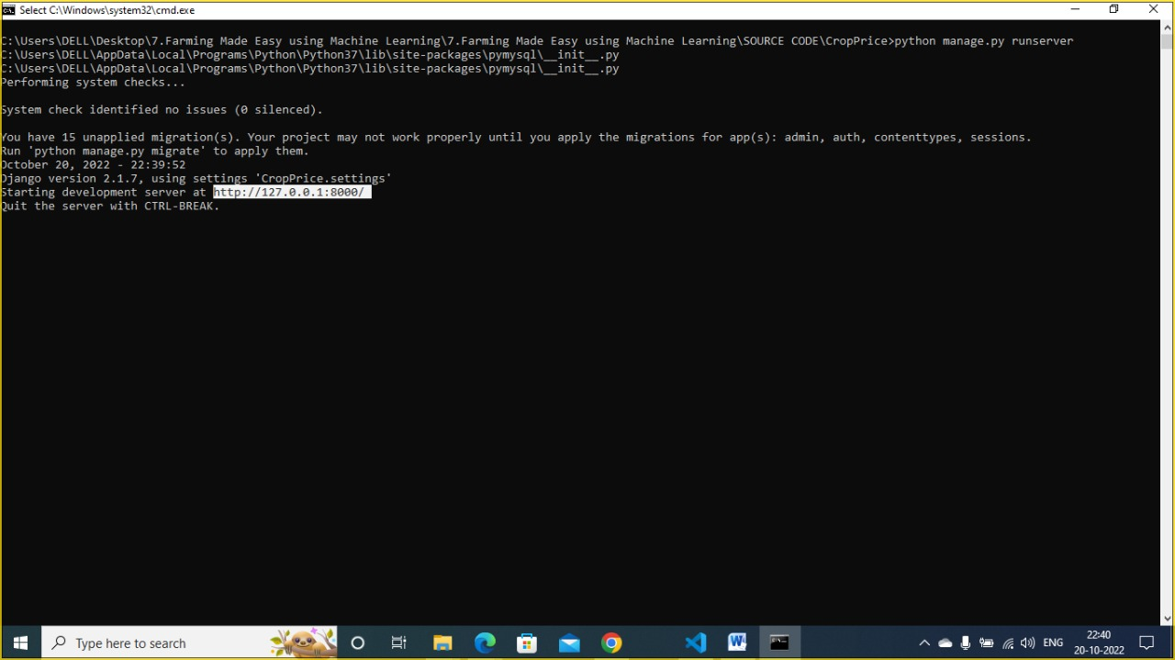

**Fig 37:** Server started and open browser and enter URL.

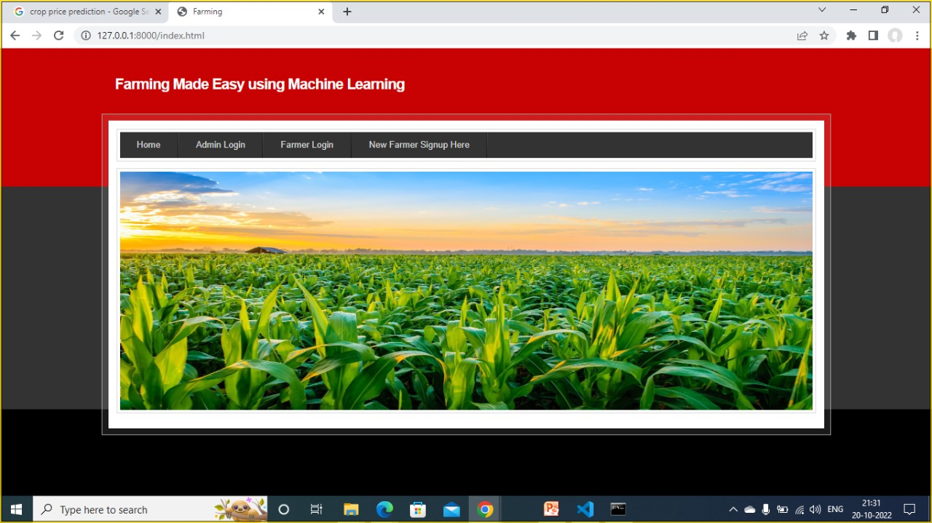

**Fig 38**: Home Page

In above screen click on ‘Admin Login’ link to get below login screen.

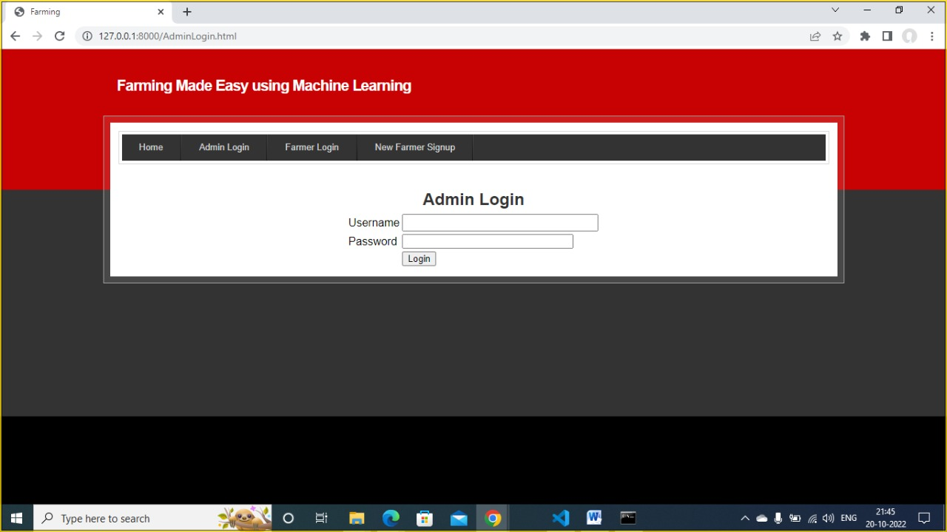

**Fig 39:** Admin Login Page

In above screen admin is login and after login we will get the below screen.

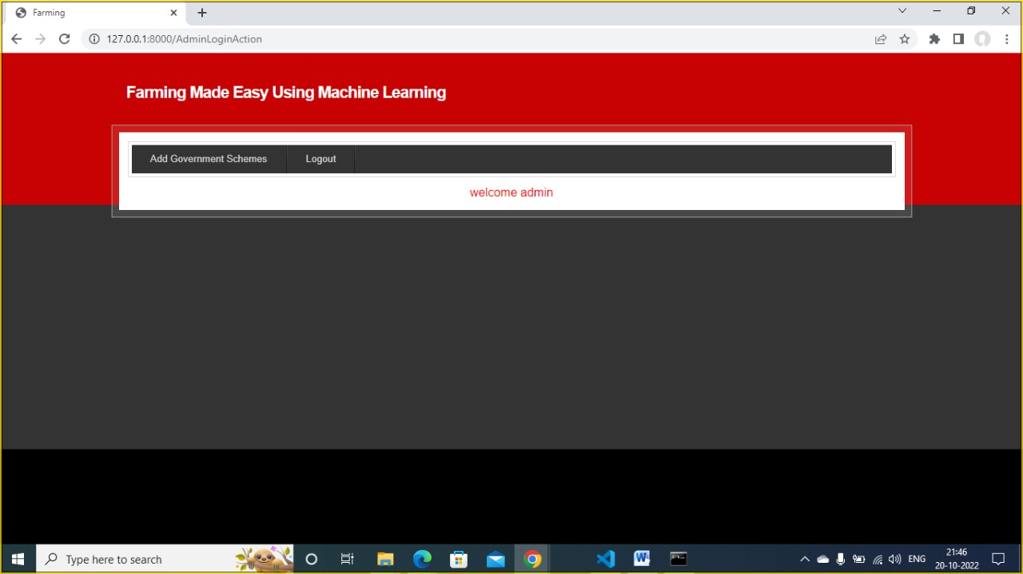

**Fig 40:** Welcome admin page

In above screen click on ‘Add Government Schemes’ link to add new schemes.

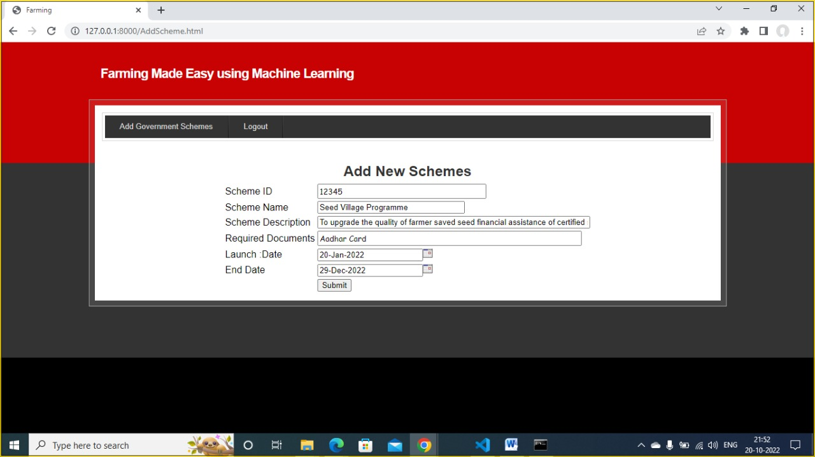

**Fig 41:** Add new schemes page

In the above screen admin will add schemes details with start and end date and then click on ‘Submit’ button to save schemes details.

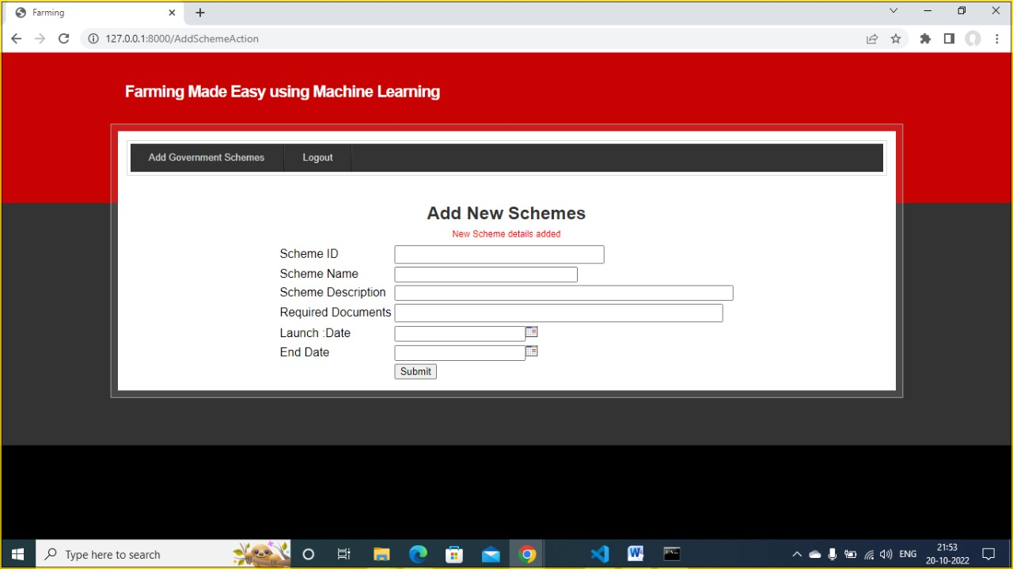

**Fig 42**: New schemes added page

In above screen in red colour text, we can see scheme details added and now logout and signup new farmer.

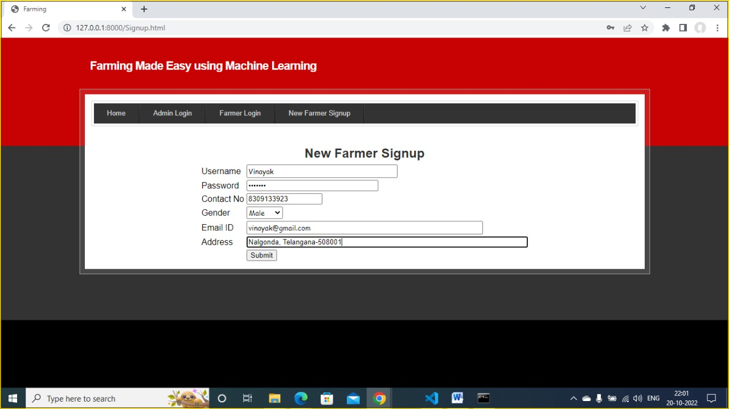

**Fig 43:** New Farmer Signup Page

In above screen farmer is signup and click on ‘Submit’ button to complete signup process.

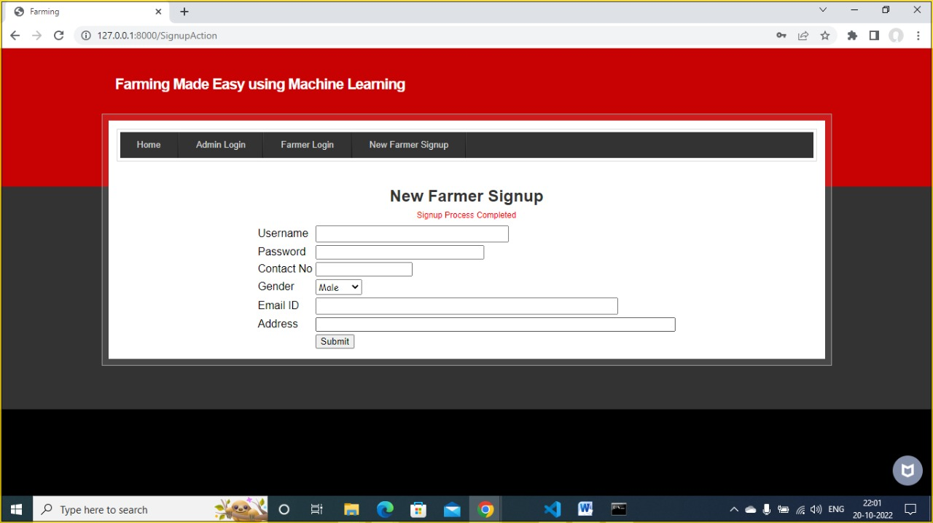

**Fig 44**: Signup Process Completed Page

In above screen signup is completed and now click on ‘Farmer Login’ link to get below screen.

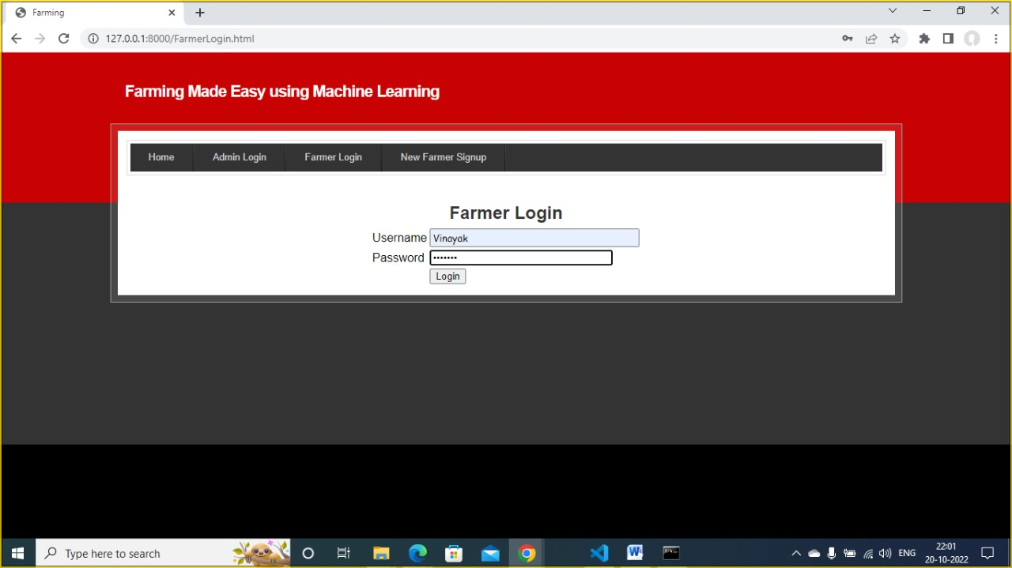

**Fig 45**: Farmer Login Page

In above screen farmer is login and click on ‘Login’ button to get below screen.

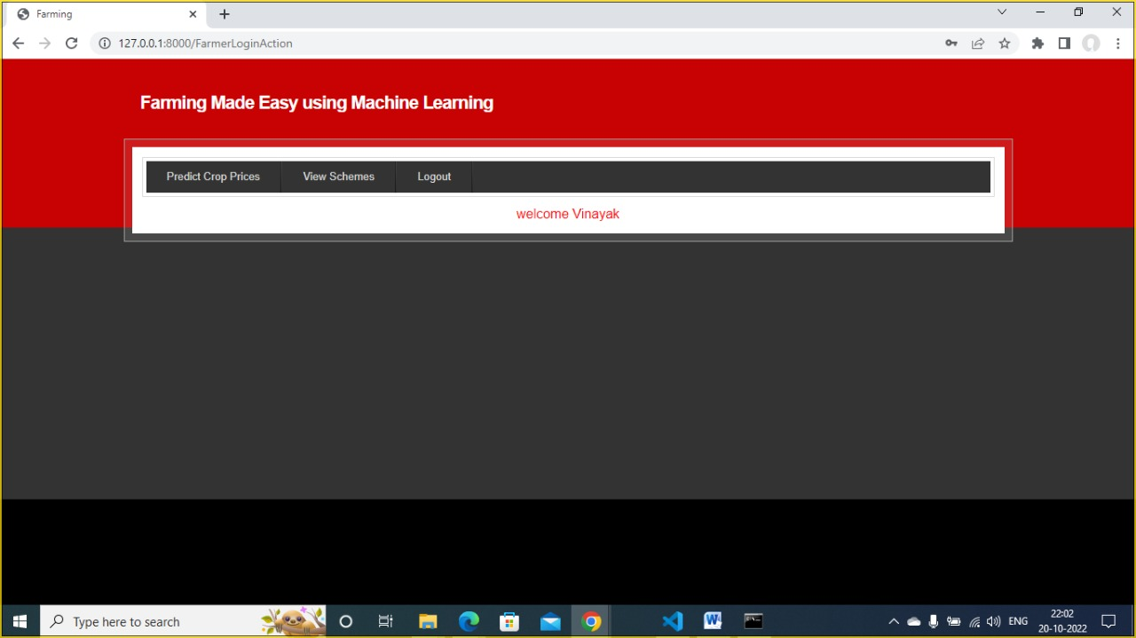

**Fig 46**: Welcome Farmer Page

In above screen farmer can click on ‘View Schemes’ link to get all schemes details.

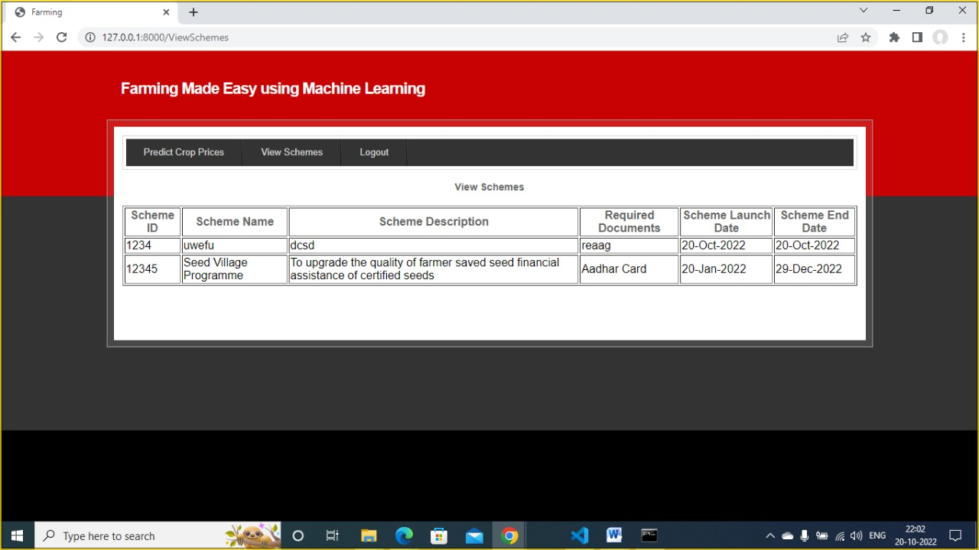

**Fig 47**: View Schemes Page

In above screen all schemes details can be viewed by farmer and now click on ‘Predict Crop Prices’ link to get below screen.

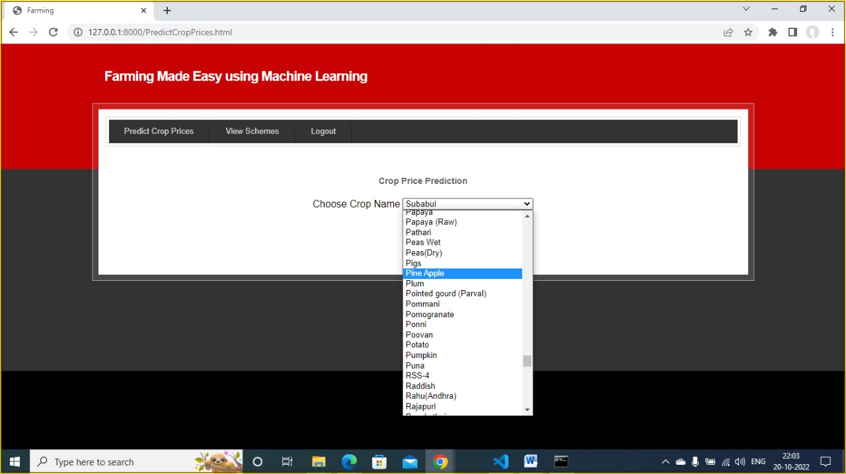

**Fig 48**: Crop Name Selection

In above screen farmer can select desired crop and then click on ‘Predict Crop Prices’ link to get below prediction.

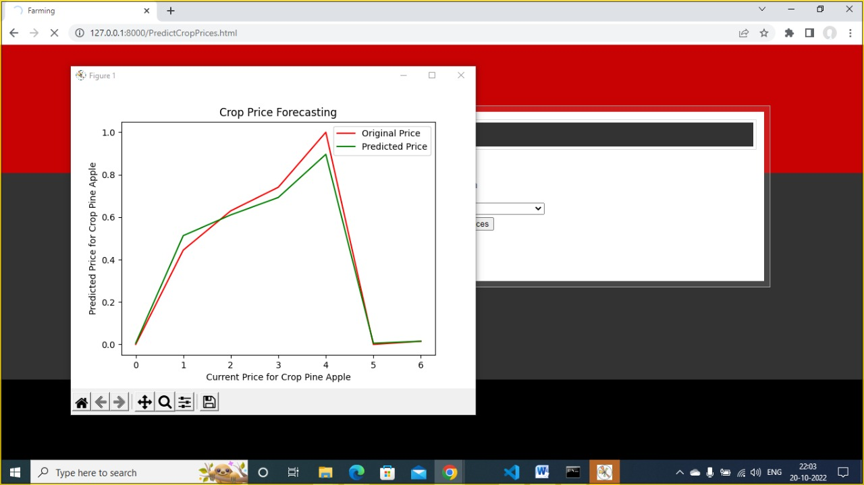

**Fig 49:** Crop Price Forecasting Graph

In above graph red line represents original prices and green line represents predicted prices and by seeing above graph farmer can understand what is current price and what will be future price and now close above graph to view predicted values.

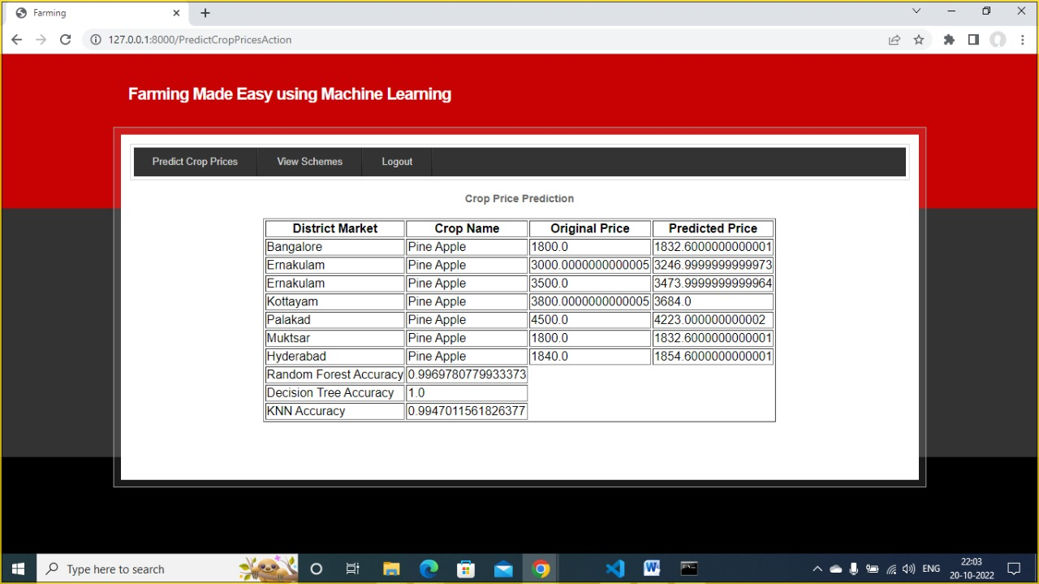

**Fig 50**: Crop Price Prediction and Accuracy

In above screen in last 3 lines, we can see Random Forest, KNN and decision tree prediction accuracy.Similarly, you can select any crop and get prediction prices.

Note: some crop contains only 3 or 4 records so prediction may not be correct as to train we need minimum 50 to 100 records. Here bhindi and coriander crop contains more records.